WEEK 7 Data Management
Data management in the app is handled through a modern, real-time cloud architecture using Firebase Cloud Firestore and Kotlin Flows.
- Cloud Database (Firestore): Instead of a local offline database, the app stores all data in Firebase Firestore collections (users, menu_items, and reservations). This acts as the single source of truth.
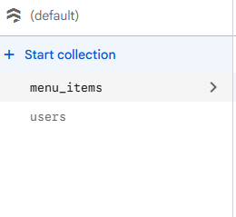
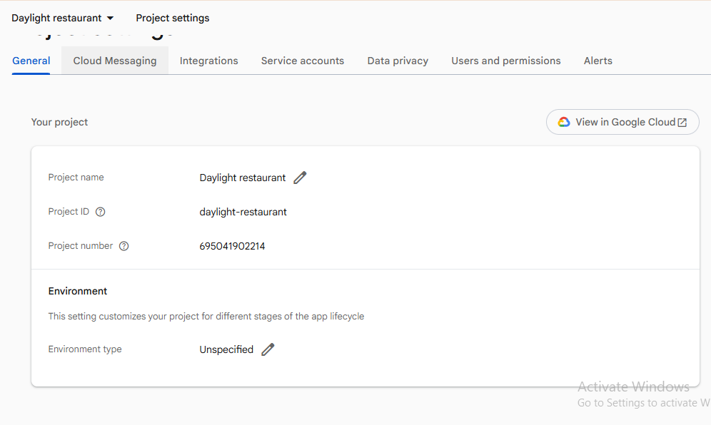
- Data Models: Data is structured into clean data classes that easily map to Firestore documents.
- Repository Layer (AppRepository): This is the central hub for data operations. It connects to Firestore and sets up real-time snapshot listeners. Whenever data changes in the cloud (e.g., an admin updates a menu item, or a user makes a reservation), Firestore pushes the update to the repository instantly.
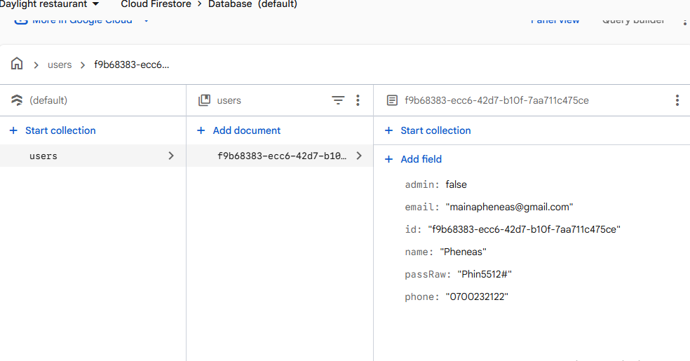
- State Management (MainViewModel): The repository exposes the data streams using Kotlin StateFlow. The MainViewModel subscribes to these streams and holds the current UI state.
- UI Layer: The Jetpack Compose screens observe the MainViewModel. Because the entire chain is reactive, any change in the cloud database automatically triggers a UI update for the user seamlessly.

